2016
State of Tennessee

Oileen Roberts

LEIE REPORTING PORTAL
The LEIE Reporting Portal will allow DIDD Employees and DIDD Providers to report monthly that they have completed the necessary checks against the List of Excluded Individuals and Entities as published on the Office of Inspector General website located at http://oig.hhs.gov/exclusions/

THIS PAGE WAS INTENTIONALLY LEFT BLANK

Contents
Where is the Portal 4
Access Information 4
Creating a Log in ID 5
Log In to LEIE Portal 8
Forgot Password 10
Monthly Reporting 15
No Exclusion to Report 16
Exclusion to Report 18
Changing What Was Reported 22
Editing No Exclusions Reported 22
Editing Exclusions Reported 23
Reports 26
Provider History View 26
What to do if you are not able to log in 27
1. Contact Regional Office 27
2. Email DIDD Help Desk 27
What to do if you need to delete a User Name 28
1. Contact Regional Office 28
2. Email DIDD Help Desk 28
GLOSSARY 29
Abbreviations 29
Error Messages 30
OIG Web Site 33

THIS PAGE WAS INTENTIONALLY LEFT BLANK

Where is the Portal
On a monthly basis Providers are required to report the status of their employees, and those they contract with, to DIDD at this location.
https://apps.didd.tn.gov/LEIEAPP/

Access Information
Providers can have two (2) users registered on the portal at any time. Each User must have his own User Name and password. When a user is no longer with the Agency the User Name should be reported to DIDD so that it can be removed from the system. This allows a new user to register on the system. Passwords expire every 90 days. Users can reset the password as anytime using the Lost Password link on the login page.
Users create their own User Name for logging into the LEIE Provider Reporting Portal. The screen below shows what information is needed, Users should have all pieces of information available before beginning the process to create a User account.
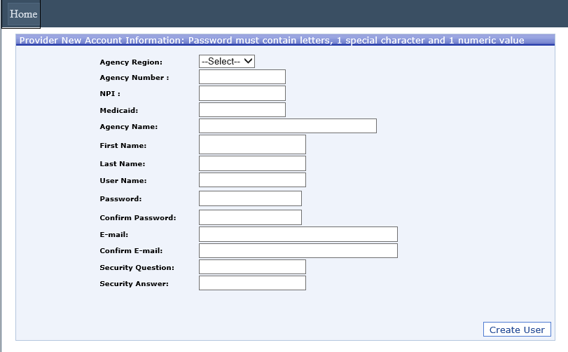

Creating a User Login Account
- Open a browser window
- Enter https://apps.didd.tn.gov/LEIEAPP/
- in the browser address bar
- Press Enter to see the home page.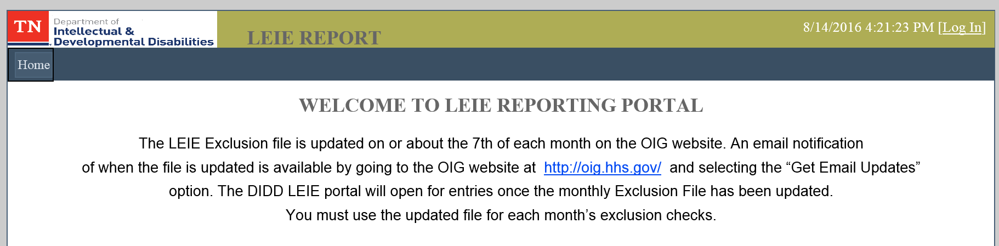
- Click the Login link on the top right hand side of the screen; this will open the login page.
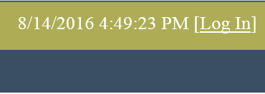
- Click the Register link to open the Provider New Account Registration screen 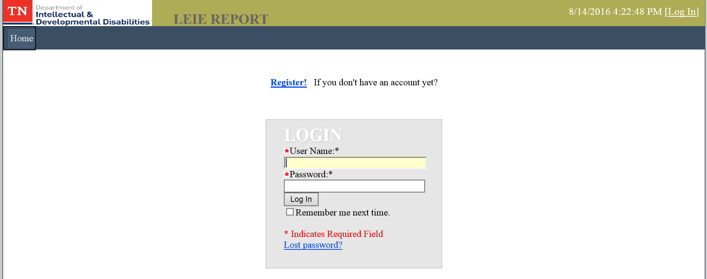
- Select a region from the drop down list
- Enter your Agency Number – the number must with two zeros, e.g. 00M25. Each agency is allowed to have two user IDs on the system
- Press the Tab key – The agency information on file will fill in (NPI, Medicaid, Agency Name)
- Enter your First Name, and Last Name in the next two fields
- For the user name field, create a user name of your choice
- Create a password in the next field. Passwords must be at least 8 characters long, it must contain a capital letter, a lower case letter, a number and a special character.
- Confirm your password in the next field
- Enter your email address in the next field. This is important as the system will respond to the email address entered here.
- Confirm the email address by entering it again
- Create a security question in the next field.
- Enter the answer to the security question created in step 15. Write down your security question and answer. This will be needed if you need to reset your password.
- Click the Create User button. 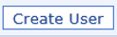 You will see the following screen
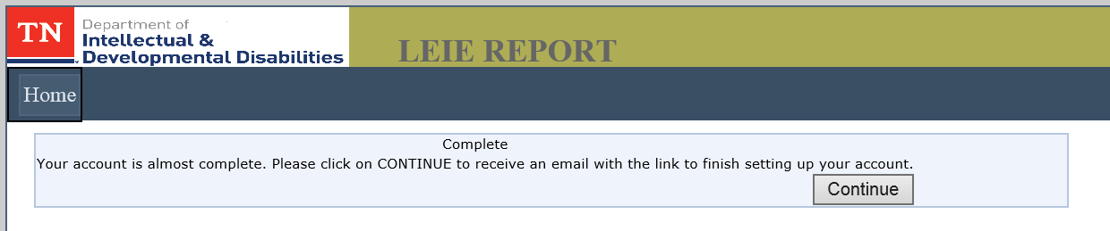
- Click the button. This will generate an email to the account entered during registration. The email will be similar to the following example.
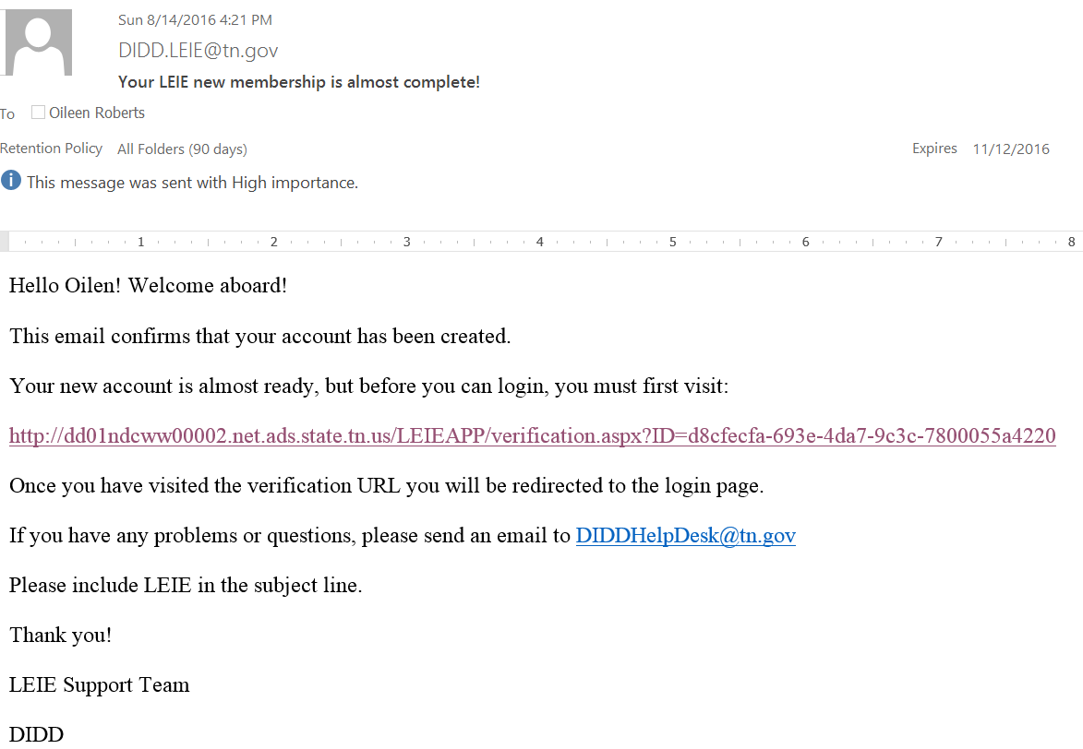 It is important to click the Continue button so that an email will be generated to the address you entered.
- Go to the email and click the link provided in the middle of the email to finish the setup process. Clicking the link will open the application and you should see the Account Verification screen. 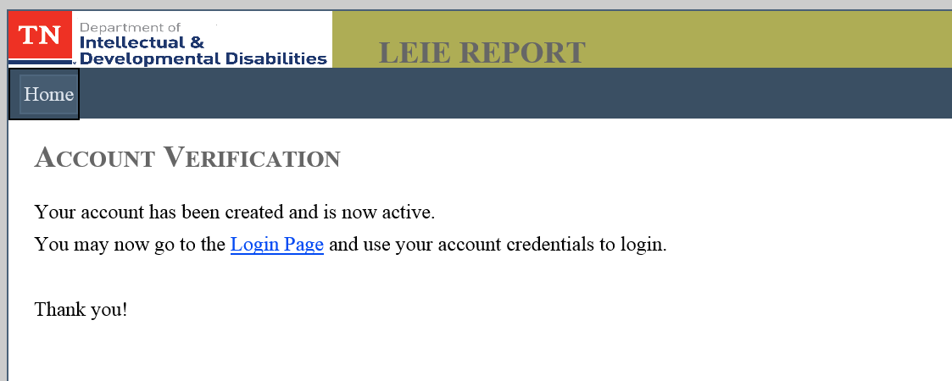
- Click the Login Page link on the screen. It will bring you to the login page where the user will enter their User Name and Password created during the setup process.

Log In to LEIE Portal
- Open a browser window
- Enterhttps://diddapps.tn.gov/LEIEAPP/ in the browser address bar
- Press Enter to see the home page.
- Click the Login link on the top right hand side of the screen, this will open the login page.
- Click in the User Name field and type your user name
- Click in the Password field and type your password
- Click the Log In button.
- User will be presented with the LEIE Home Screen
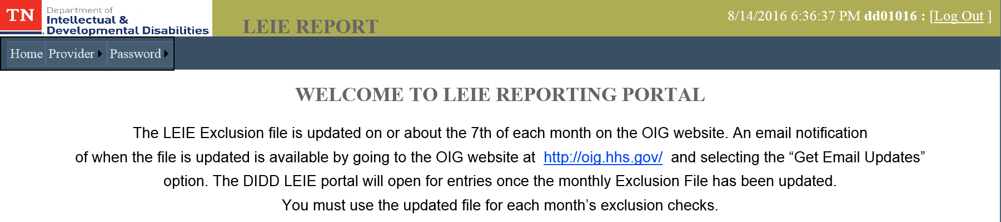
Note: The Log In became changed to become the Log Out button.

Forgot Password
Every 90 days the system will force users to change the password used to access the system. User may also change his/her password at any time. The following instruction are for changing your password.
- Open your browser and type the link to the LEIE Reporting Portal: https://diddapps.tn.gov/LEIEAPP/
- Click the Login Link on the top right side of the screen.
The login screen opens.
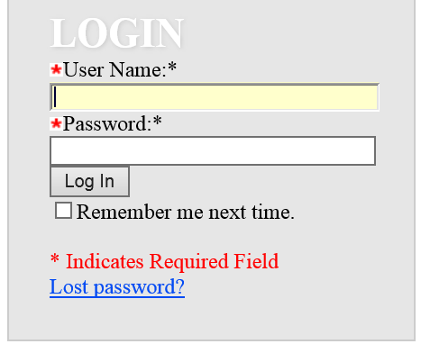
- Click the Lost Password? link to bring up the Forgot Your Password? screen
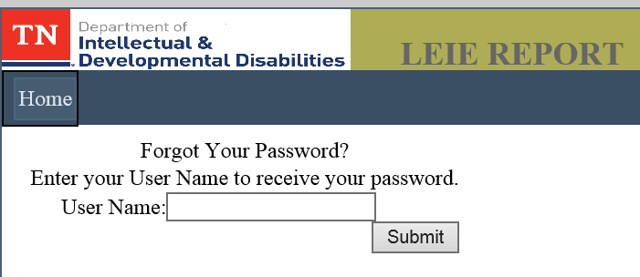
- Enter your User Name and click the  button to bring up the Identity Confirmation screen
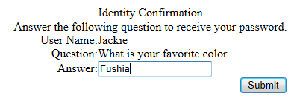.
- Enter the Answer to the security question and click . If the answer is correct the system will respond with the following screen. 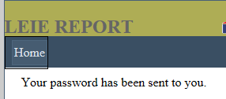
- Log into the email address used to set up the account to retrieve a temporary password. The email will look similar to this. 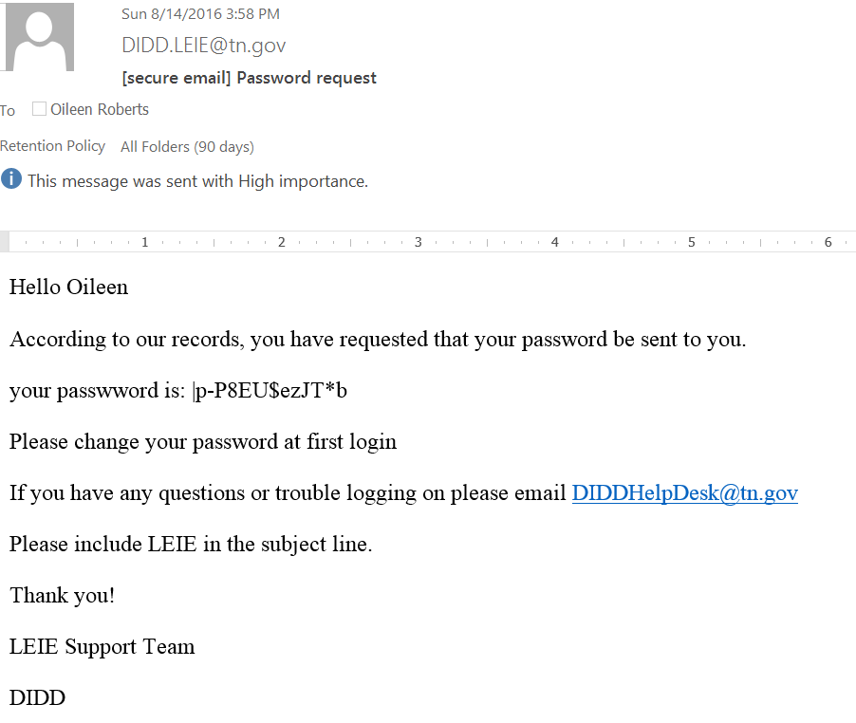
- Highlight the password in the email, right click, and copy.
- Go to the LEIE Login Screen, right click in the Password field and click Paste
- Click in the User Name field and enter the associated user name. 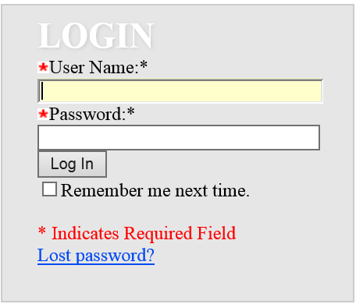
- Click the Log In button. 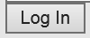This will log the user into the application and the user should see the following LEIE Home Page Screen
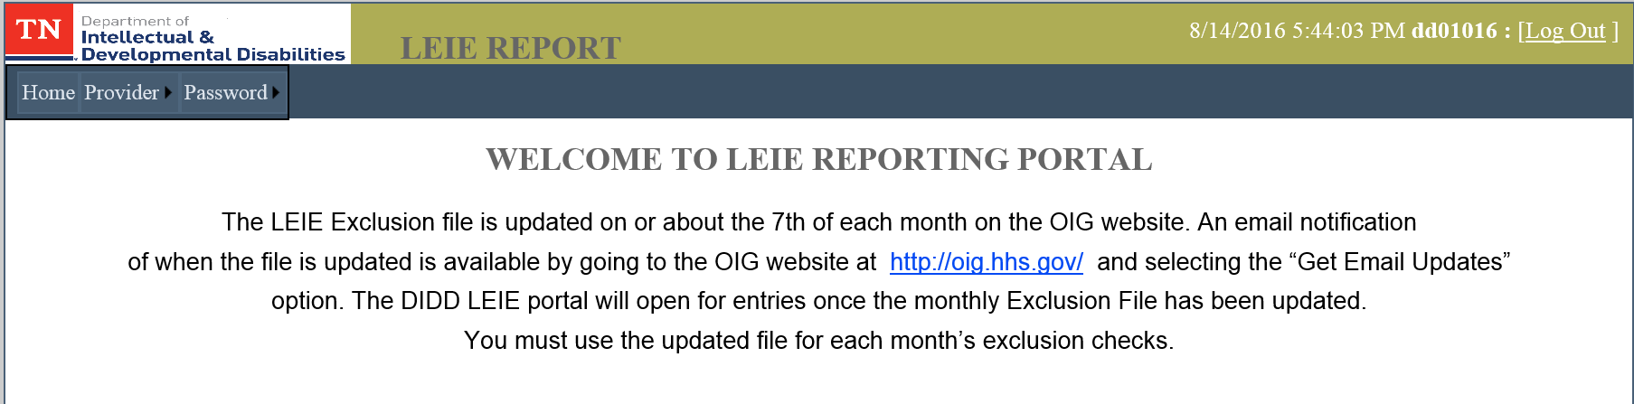
Users are advised to immediately change the password to something that the user can remember. Here are the steps.
- Click on Password at the top of the screen then click Change Password.
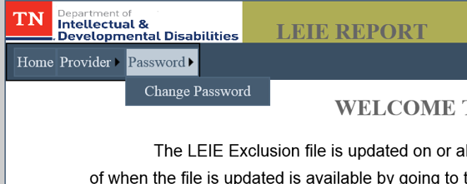
- The Change Your Password screen opens and will contain the User Name. 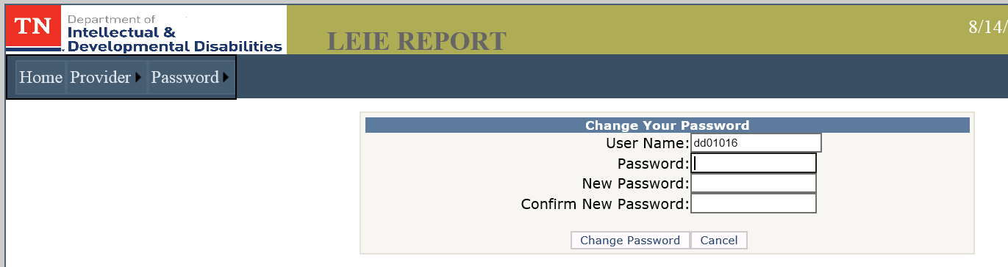
- Click in the Password field, right click, select Paste. The temporary password is entered in the Password field. 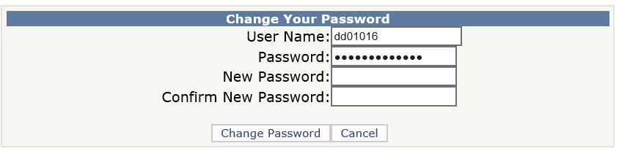
- Click in New Password field and create a new password that follows the password rules. A password must contain a capital and lower case letter, a number and a special character.
- Click in the Confirm New Password field and retype the password. If the passwords don’t match the system will generate a message.
- Click the Change Password button. The system will return the following screen.
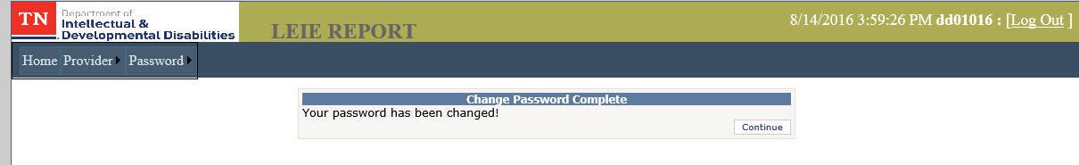
- Click Continue. You can now log out of the system and try your new password.

Monthly Reporting
All Providers who provide services to Individuals with Intellectual and Developmental Disabilities (IDD) are required to search for each employee and contractor on the Office of Inspector General (OIG) List of Excluded Individuals and Entities (LEIE) each month. Providers are also required to report back to the Department of Intellectual and Developmental Disabilities (DIDD) any findings. The report is required by the 15th of each month. When the 15th falls on a Saturday, Sunday or a state holiday, Providers are given to the next business day to report.
Providers are prohibited from reporting until DIDD enters the updated date for the current month. This is the date that can be found on the OIG Exclusions page as shown below. Providers can sign up to be sent an email when this page is updated. The location to sign up can be found at this web address: https://oig.hhs.gov/exclusions/exclusions_list.asp
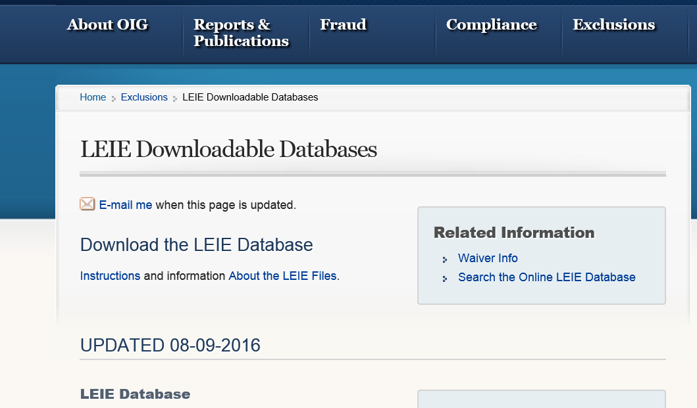
A compliant report is one that is done on an updated database for that month and reported to DIDD within the reporting time frame for that month. For example: For the month of August, the OIG updated date must be an August date as shown in the example above and the Provider must have reported its findings to DIDD on or before August 15.

No Exclusion to Report
A Provider with no Exclusions to report must still report that information to DIDD. A form is provided on the portal that accommodates the information.
- Log into the LEIE Reporting Portal
- Hoover over Provider, click Provider Data. The following message will be displayed when the Portal is not ready for reporting. Providers can still log in and view previously submitted data.This screen is presented after the OIG Date has been added to the portal.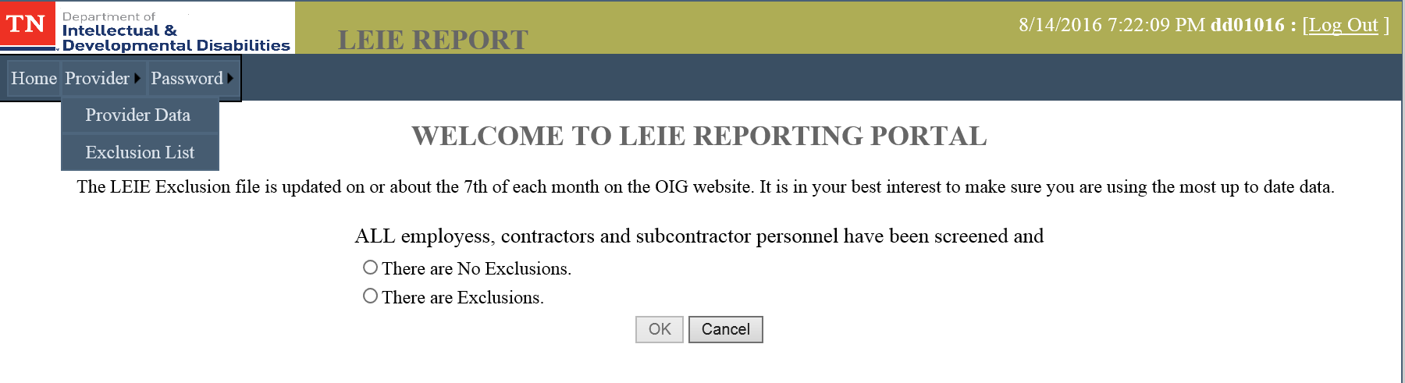
- Respond to the question presented on the screen by clicking a radio button
“ALL employees, contractor and subcontractor personnel have been screened and
Ο There are No Exclusions;
Ο There are Exclusions.”
Click OK.
- For the option “There are No Exclusions,” the Reporting screen presented will only contain two empty fields.
- Enter the date of the OIG Exclusion Data File Used
Note: Enter two digits for the Month, two digits for the Day, and four digits for the Year separated by “/”.
Enter the date the exclusion check was completed, Note: Enter two digits for the Month, two digits for the Day, and four digits for the Year separated by “/”.
- Click to exit without saving the data.
- Click to save the data.
- Once the Submit button has been clicked, users will receive a confirmation page that can be printed and kept for proof of submitting a timely report. 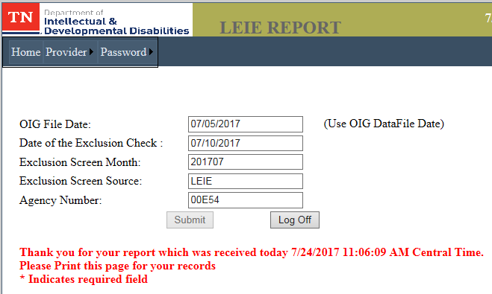
- There are some error messages that may be seen while reporting and are there to assist the user with reporting correctly.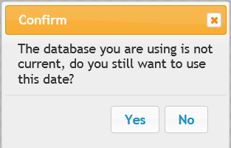 This message indicates that the date you entered in the Date of Exclusion Data File Used field is not for the current month. Click 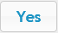 to continue with reporting. Click  to go back and correct the date.

Exclusion to Report
A Provider with no Exclusions to report must still report that information to DIDD. A form is provided on the portal that accommodates the information.
- Log into the LEIE Reporting Portal
- Hoover over Provider, click Report Data. The following message will be displayed when the Portal is not ready for reporting. Providers can still log in and view previously submitted data.This screen is presented after the OIG Date has been added to the portal.
- Respond to the question presented on the screen by clicking a radio button
“ALL employees, contractor and subcontractor personnel have been screened and
Ο There are No Exclusions;
Ο There are Exclusions.”
Click .
- For the option “There are Exclusions,” a new data entry screen is provided.
- Note: Enter two digits for the Month, two digits for the Day, and four digits for the Year separated by “/” for all fields requiring a date.
- Use the information from the OIG website to complete the form. Please cut and paste as much of the information as you can so that the data submitted is accurate.
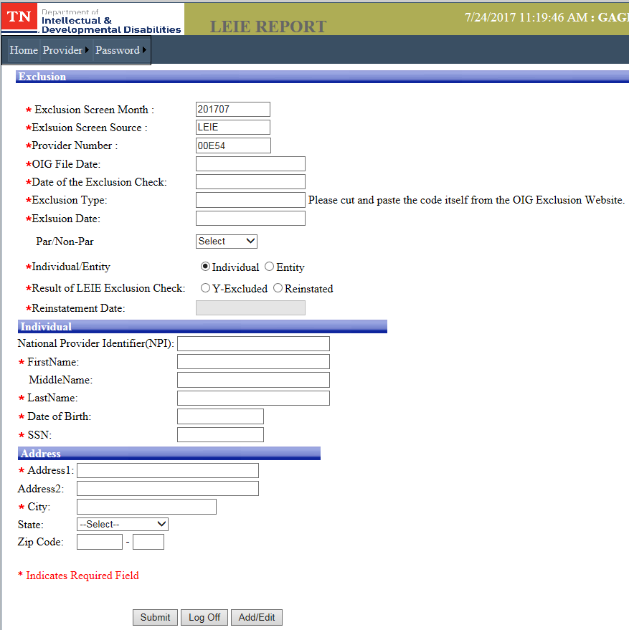
- This is a sample blank screen to report Exclusions. Asterisks (*) indicate required fields
- The button allows you to log off before submitting the data. Click the button to report to DIDD.
- Once the Submit button has been clicked, users will receive a confirmation page that can be printed and kept for proof of submitting a timely report. 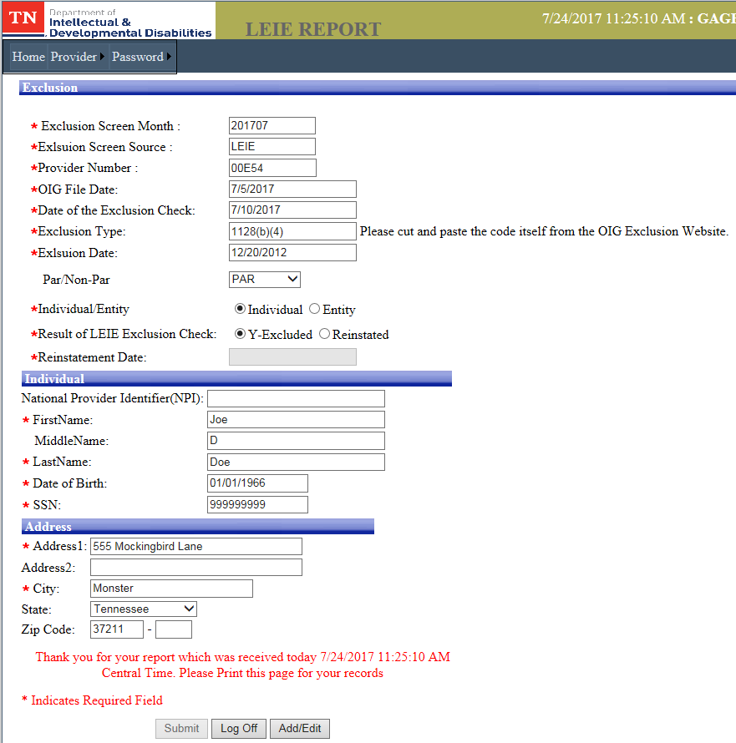
- Once the user submits the data the screen refreshes with a message in red to print the screen for your records.
- To add another record, click the button. This will remove the data that was previously submitted so that the user may enter another Exclusion button. The previously submitted data is saved.
- There are some error messages that may be seen while reporting and are there to assist the user with reporting correctly. This message indicates that the date you entered in the Date of Exclusion Data File Used field is not for the current month. Click to continue with reporting. Click to go back and correct the date.

Changing What Was Reported
To change any data that has been submitted you must first delete the previously submitted entry. The system will not allow you to delete any data for a previous month once the end of the month is past. In other words if it is August 1 and you want to change what was reported on July 10 you will not be able to do so.

Editing No Exclusions Reported
- Log into the LEIE Reporting system with your user ID and password
- Click on Provider and select Provider Data. If you have already reported no exclusions for the month, you should get this screen. 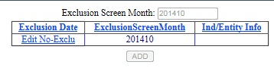
- Click Edit No-Exclusion in the left column and you will get the screen with the data you submitted. 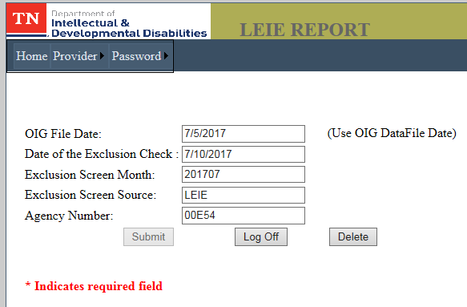
- Click the button to remove what was previously reported. This will take you back to answer the Attestation Question again.
- Answer the question again to receive the appropriate form for reporting.
- Click to send the corrected information. You will get a message to print the page for your records.
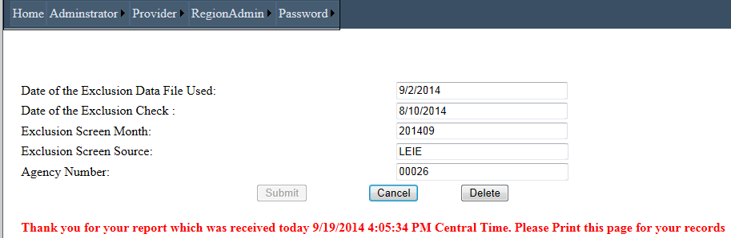
- The button logs you out the system.
- The button will remove the record completely from the system and allow you to resubmit a new report with the current date.

Editing Exclusions Reported
- Log into the LEIE Reporting system with your user ID and password
- Click on Provider and select Provider Data. If you have already reported Exclusions for the month, you should get this screen.
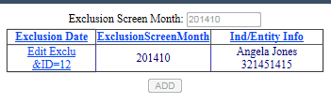
- Click Edit Exclu&ID=xx link in the left column and you will get the screen with the data you submitted
- The only fields on the screen presented that you may not change are
  - Exclusion Screen Month;
  - Exclusion Screen Source;
  - Provider Number; and
  - Individual/Entity selection
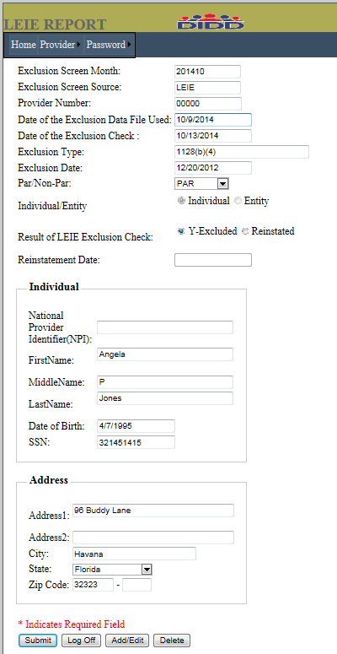
- Click the button to remove what was previously reported. This will take you back to answer the Attestation Question again.
- Answer the question again to receive the appropriate form for reporting.
- The button will allow you to re-submit your data, but only prior to the monthly cutoff date (15th.)
- The button will undo any changes and log you out of the system
- The button will remove submitted data from the screen with the exception of
  - Exclusion Screen Month
  - Exclusion Screen Source
  - Provider Number
The user can then add another record if necessary.
- will erase the data on the screen from the database and return you to this screen to allow you to enter a new record.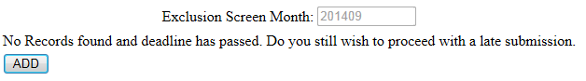

Reports

Provider History View
The LEIE Portal will allow Providers to see the information that has been submitted previously to DIDD in summary format.
- Log into the LEIE Reporting system with your user ID and password
- Click on Provider and select Exclusion List.
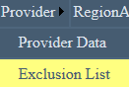
- You should get a list of items under the following headings if you have reported previously.
Depending on what was reported there could be blank columns on your view.

What to do if you are not able to log in
Users who are not able to log in can contact their Regional Office directly or the DIDD Help Desk. However Users should first check to see if the OIG updated date has a date in the current month. User will be locked out of reporting until the OIG has updated it’s LEIE list.

Contact Regional Office
Regional Contacts are:

East
- Janet Kinley, Janet.Kinley@tn.gov, 423-787-6495
- Tammy Green, Tammy.R.Green@tn.gov, 423-787-7491

Middle
- Crissonya Phillips, Crissonya.Phillips@tn.gov, 615-231-5092
- Michael Ledbetter, Michael.Ledbetter@tn.gov, 615-231-5173

West
- Monda Qualls, Monda.Qualls@tn.gov, 731-421-5175

Email DIDD Help Desk
If the Provider chooses to contact the DIDD Help Desk the following information should be provided on the email.
- LEIE in the subject line
- Include Provider Number, User Name in the body of the email
- Email what the problem is
- Include a telephone number for a call back
Send this information via email to DIDDHelpDesk@tn.gov.

What to do if you need to delete a User Name
Providers may contact their Regional Office directly or the DIDD Help Desk.

Contact Regional Office
If the Provider chooses to contact their Regional Office the following information should be provided.
- LEIE in the subject line
- Include Provider Number, User Name in the body of the email
- User ID that must be deleted
- Include a telephone number for a call back
Regional Contacts are:

East
- Janet Kinley, Janet.Kinley@tn.gov, 423-787-6495
- Tammy Green, Tammy.R.Green@tn.gov, 423-787-7491

Middle
- Crissonya Phillips, Crissonya.Phillips@tn.gov, 615-231-5092
- Michael Ledbetter, Michael.Ledbetter@tn.gov, 615-231-5173

West
- Monda Qualls, Monda.Qualls@tn.gov, 731-421-5175

Email DIDD Help Desk
If the Provider chooses to contact the DIDD Help Desk directly, the following information must be included in the email.
- LEIE in the subject line
- Include Provider Number in the body of the email
- User ID that must be deleted
- Include a telephone number for a call back
Send this information via email to DIDDHelpDesk@tn.gov.

GLOSSARY

Abbreviations
Abbreviation | Explanation
DIDD | Department of Intellectual and Developmental Disabilities
EIN | Employer Identification Number. Entities will have an EIN. The formation will be 12-3456789.
ID | Identification, this is usually used with the words Log in, as in Log in ID. The ID is created when you first register on the system and is used in conjunction with a password to gain access to the application. For LEIE the ID will be referred to as a User Name.
LEIE | List of Excluded Individuals and Entities
NPI | National Provider Identifier. This is a 10-digit number with no spaces or special characters. An Individual or an Entity may have a National Provider Identifier.
OIG | Office of Inspector General
SSN | Social Security Number. Only Individuals will have a SSN. The format is 123-45-6789. Companies will have an Employer Identification Number (EIN).

Error Messages

Error Message in LEIE Portal | Explanation
Address1 is Required! | There are two lines for address. The first line is required, the second line is optional. Enter an address in the first address field.
Agency already has 2 registered users! | Only two user IDs are allowed on the system for your agency.
Agency Number is required. | Enter your Agency Number
City is Required! | The address is not complete without a City. Enter your city.
Confirm Password is Required | During the registration process you will need to enter a password. Passwords must be 8 or more characters and must contain a special (!@#$%&*) characters and at least one number. You must enter it the second time in the Confirm Password field.
Date of Birth is Required! | Enter the individual’s date of birth.
Date of Exclusion is Required! | If reporting an Exclusion please enter the date found on the OIG website for the individual or entity you are reporting on.
Date of Exclusion Check is Required! | This is the date you performed the check.
Date of Exclusion Data File Used is Required! | Enter the updated date of the OIG file. This date can be found on the OIG web site here: http://oig.hhs.gov/exclusions/exclusions_list.asp
EIN is Required! | The Employer Identification Number is required.
Email is Required | The LEIE system uses an email address to assist you with registering and also with recovering or changing your password. Please enter your email address.
Entity Name is Required! | For entities, a company (entity) name is required.
First Name is Required! | For individuals, a first name is required.
Invalid AgencyID and/or Region. | Select the Region from the drop down list and also enter your agency number
Last Name is Required! | For individuals, a last name is required.
Password is required | On the log in screen or when registering for the first time, enter your password before clicking the or buttons.
Phone Number is Required | Enter your telephone number in the following format: 651-391-9800
Please enter a valid ZipCode! | A zip code must be entered.
Please enter Date of Exclusion in MM/DD/YYYY format! | The date format for Date of exclusion must be entered as MM/DD/YYYY, e.g. 09/09/2014
Please select an option for Exclusions! | You must check a box before you submit your report. Click on the pop up error screen and make a selection on the Attestation page.
Please select Result of LEIE Exclusion Check! | Select one of the three radio buttons: Excluded, Not Excluded, Reinstated. If Reinstated is selected you will also need to enter a reinstatement date in the field below the selected radio button.
Please select State! | Select the state from the drop down field.
Reason for Exclusion is Required! | Information was not included in this field. You can find this information on the OIG web site.
Required Fields | Fields that are required are marked with an (*). You will not be allowed to proceed until these fields are completed.
Security answer is required | The answer to the security question must be entered in this field. Please write down your security question and the answer that you typed. You will need it to recover your password.
Security question is required | A question of your choice must be entered in this field. It cannot be blank.
SSN is Required! | For individuals, please enter the social security number.
Thank you for your report which was received today 9/22/2014 3:06:25 PM Central Time. Please Print this page for your records | Message displayed when a report is submitted to DIDD. Print this page for your records.
The database you are using is not current; do you still want to use this date? | The data entered in the Date of Exclusion Data File Used field is not the most current. Check the date again at the OIG website here http://oig.hhs.gov/exclusions/exclusions_list.asp
User Name Required or  User Name is Required | On the log in screen or when registering for the first time, enter your User Name and Password before clicking the or buttons.
User Name: * | An (*) asterisk beside a field indicate a required field.
We were unable to access your information. Please try again | The User Name you entered cannot be verified, re-enter your User Name.
Your answer could not be verified. Please try again | The answer to the security question could not be verified. Reenter the answer and click

OIG Web Site
The online searchable database can be found here: http://exclusions.oig.hhs.gov
The OIG Website Reference information can be found here: http://oig.hhs.gov/faqs/exclusions-faq.asp
The Exclusion List is updated monthly. The date the website is updated, which is the date that should be reported to DIDD each month can be found here: http://oig.hhs.gov/exclusions/exclusions_list.asp
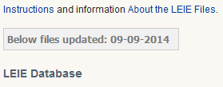
This screen shows the date for September 15, 2014 reporting. When reporting in September 2014 you would report the Exclusion Data File Used date as 09/09/2014.

