Level One
Level Two
Level Three
FASHION DESIGN
__________

Arts, A/V Technology, & Communications
__________

Level Four

ABOUT THE PROGRAM OF STUDY
Dual credit/ dual enrollment options include:
Course A
Course B

The Fashion Design program of study prepares students for further education and careers in the fashion industry. In addition to learning skills and knowledge related to the elements and principles of design, apparel manufacture and merchandising, basic marketing and product promotion, trend forecasting, and presentation, students complete a capstone project during which they design an original fashion line and create artifacts to include in a professional portfolio. Upon completion of this program of study, students will be prepared for postsecondary study and careers in fashion design and fashion merchandising. Students may gain job experience while still in high school through work-based learning.
This is not an exhaustive list of all of the opportunities available in Tennessee.

Merchandise displayers and window trimmers, $27,050
Sewing machine operators, $21,620
Tailors, dressmakers, and custom sewers, $23,910
Retail salespersons, $23,690
Wholesale and retail buyers, $49,640

High School Diploma

First-line supervisors of retail sales workers, $35,950

Certificate

Wholesale and retail buyers, $49,640
First-line supervisors of retail sales workers, $35,950

Associates

Fashion designers, $56,800

Bachelors
Occupation | Total Percent Change | Annual Avg. Openings
Retail Salespersons | 5.10% | 3,585
First-Line Supervisors of Retail Sales Workers | 1.50% | 845
Laundry and Dry-Cleaning Workers | 1.20% | 135
Wholesale and Retail Buyers, Except Farm Products | 3.20% | 85
Merchandise Displayers and Window Trimmers | 9.10% | 85
Sewing Machine Operators | -6.30% | 25
Tailors, Dressmakers, and Custom Sewers | -8.90% | 15
Fashion Designers | ** | **

Fashion Design Related Occupations with the Most Annual Average Openings in Tennessee (2014-2024)
CAREER OPPORTUNITIES
Nationally, the fashion designer occupation is projected to grow by 3 percent between 2014 and 2024, slower than average for all occupations. Job outlook for fashion designers is very competitive due to the large number of training completers in relation to the number of job openings. Occupations related to fashion design include retail sales workers, merchandise displayers and window trimmers, and those related to fashion manufacturing. In Tennessee, Nashville is home to over 150 fashion brands.

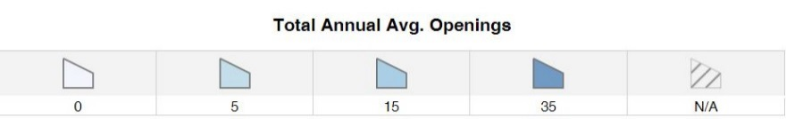
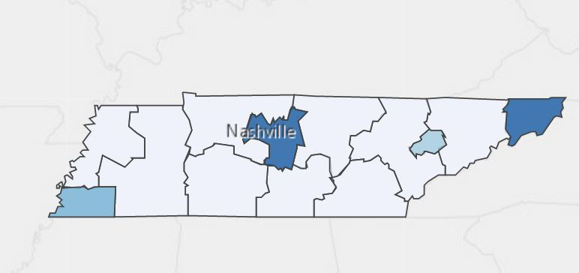
Annual Average Openings for Merchandise Displayers and Window Trimmers in Tennessee (2014-2024)

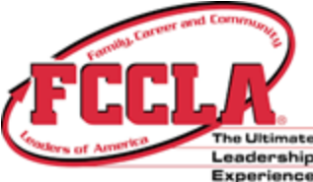Students in this program of study will be eligible to join FCCLA, Family, Career and Community Leaders of America. In addition to school events, students will be able to compete at the district, state, and national level. Involvement in FCCLA offers students the opportunity to expand their leadership potential and develop skills for life—planning, goal setting, problem solving, decision making, and interpersonal communication—necessary in the home and workplace. Walk away from your high school career with experience in competing, networking, applying course content, and more! See your adviser to learn more about FCCLA or visit http://www.tennesseefccla.org.

POSTSECONDARY OPTIONS

School | Degree Program
Nashville State Community College | 3D Design and Graphics
Nashville State Community College | Art- Studio
For more college and career planning resources, visit http://collegefortn.org.



community college, or some 2-year university programs for free! To learn more, please see your school counselor or visit http://www.tennesseepromise.gov.

For more information, contact:
School High School
County Name Schools
CTE Director: Name
Email
Instructor: Name
Email

Have you registered for the Tennessee Promise? Seniors enrolled in this program have the chance to attend a two-year program at a Tennessee College of Applied Technology (TCAT), community college, or some 2-year university programs for free! To learn more, please see your school counselor or visit http://www.tennesseepromise.gov.

