EXERCISE PHYSIOLOGY
Health Science
Level Four
Level Three
Level Two
Level One

ABOUT THE PROGRAM OF STUDY
Exercise Physiology is designed to prepare students to pursue careers in kinesiology and exercise physiology services. Upon completion, proficient students will be able to apply concepts of anatomy and physiology, physics, chemistry, bioenergetics, and kinesiology to specific exercise science contexts. Through these connections students will understand the importance that exercise, nutrition, and rehabilitation play in athletes or patients with debilitating or acute metabolic, orthopedic, neurological, psychological, and cardiovascular disorders.
Dual Enrollment Options Include:
- Dual Enrollment Anatomy and Physiology
- Dual Enrollment Exercise Physiology

This is not an exhaustive list of all of the opportunities available in Tennessee.

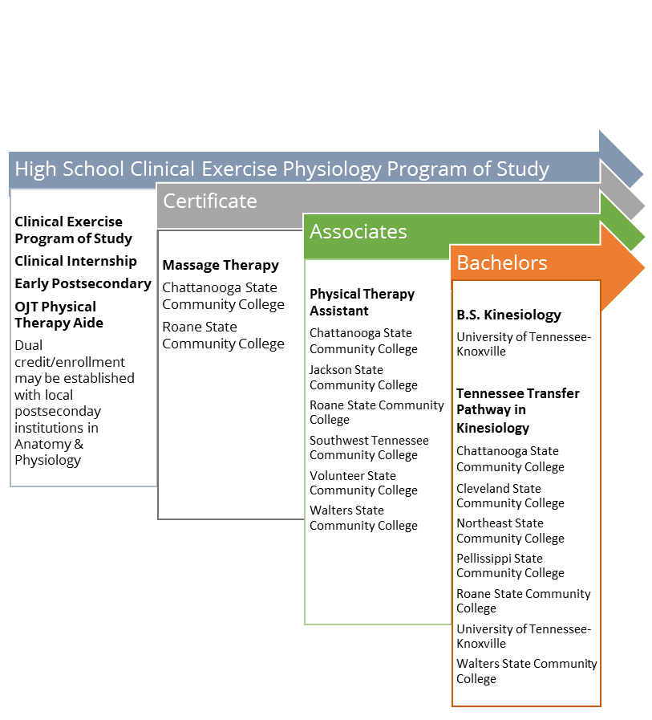
2024 Projected Employment for Exercise Physiology Related Occupations In Tennessee
Occupations | Total Percent Change | Total Annual Av. Openings
Personal Trainer | 15.3% | 120
Massage Therapist | 27.7% | 60
Physical Therapy Assistant | 56% | 180


Students in this program of study will be eligible to join HOSA: Future Health Professionals. In addition to school events, students will be able to compete at the regional, state, and national level.
HOSA's two-fold mission is to promote career opportunities in the health care industry and to enhance the delivery of quality health care to all people. HOSA's goal is to encourage all health occupations instructors and students to join and be actively involved in the HSE-HOSA Partnership. HOSA provides a unique program of leadership development, motivation, and recognition exclusively for secondary, postsecondary, adult, and collegiate students enrolled in HSE programs. HOSA is 100% health care! For more information, please visit http://www.hosa.org .

For more information, contact:
School High School
County Name Schools
CTE Director: Name
Email
Instructor: Name
Email

Postsecondary Offerings Aligned to this Program of Study
School | Degree Program
Chattanooga & Roane Community College | Massage Therapy Certificate
University of Tennessee Knoxville | B.S. Kinesiology
For more college and career planning results, visit http://collegefortn.org

CAREER OPPORTUNITIES

Nationally, employment of exercise physiologists is projected to grow 8 percent from 2014 to 2024, faster than the average for all occupations. Demand may rise as hospitals emphasize exercise and preventive care as part of their treatment and long-term rehabilitation from chronic diseases. State employment figures are more robust with projected annual job openings for personal trainers at 125 annual job openings and a total percent change from 2014-2024 of 15.3 percent.
Source: BLS.gov
2024 Projected Employment for Physical Therapy Assistants in Tennessee 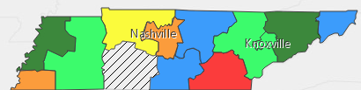



Have you registered for the Tennessee Promise? Seniors enrolled in this program have the chance to attend a two year program at a Tennessee College of Applied Technology (TCAT), community college, or some two year university programs for free! To learn more, please see your school counselor or visit http://www.tennesseepromise.gov .

